DAY-12 HDOC
Name - Aryan Pathak
Sap id- 590033176
Batch- 15

Algorithm
Main Algorithm
- Start.
- Input a positive integer number.
- If number <= 0, display an invalid input message and stop.
- Display the menu:
◦ 1: Find the sum and product of the first and last digits.
◦ 2: Count digits lesser than, equal to, and greater than k.
- Input the user's choice.
- Use a switch-case statement to perform the selected operation.
- Stop.
Case 1: Sum and Product of First and Last Digits
- Find the last digit:
last = number % 10
- Store number in temp.
- Repeatedly divide temp by 10 until temp < 10.
- The remaining value of temp is the first digit.
- Calculate:
sum = first + last
- Calculate:
product = first * last
- Display the sum and product. Case 2: Compare Each Digit with k
- Input digit k.
- Check that k is between 0 and 9.
- Initialize:
lesser = 0, equal = 0, greater = 0
- Store number in temp.
- Repeat while temp > 0:
◦ Find digit using digit = temp % 10.
◦ If digit < k, increment lesser.
◦ Else if digit == k, increment equal.
◦ Else, increment greater.
◦ Remove the last digit using temp = temp / 10.
- Display all three counts.

Test Case Table
Test Case | Input(s) | Expected Output(s) | Actual Output(s) | Res ult
1 | Number = 12345, Choice = | Sum = 6, Product = 5 | Sum = 6, Product = 5 | Pass
2 | Number = 12345, Choice = 2, k = 3 | Lesser = 2, Equal = 1, Greater = 2 | Lesser = 2, Equal = 1, Greater = 2 | Pass
3 | Number = 50705, Choice = | Sum = 10, Product = 25 | Sum = 10, Product = 25 | Pass
4 | Number = 55521, Choice = 2, k = 5 | Lesser = 2, Equal = 3, Greater = 0 | Lesser = 2, Equal = 3, Greater = 0 | Pass

C Program
#include <stdio.h> int main() { long long number, temp; int choice; int first, last, digit, k; int lesser = 0, equal = 0, greater = 0; printf("Enter a positive integer: "); scanf("%lld", &number); if (number <= 0)
{ printf("Invalid input. Please enter a positive integer.\n"); return 0;
}
printf("\n----- MENU -----\n"); printf("1. Find sum and product of first and last digits\n"); printf("2. Count digits lesser than, equal to, and greater than k\n"); printf("Enter your choice: "); scanf("%d", &choice); switch (choice)
{ case 1: /* Find last digit */ last = number % 10; /* Find first digit */ temp = number; while (temp >= 10)
{ temp = temp / 10;
} first = temp; printf("\nFirst digit = %d\n", first); printf("Last digit = %d\n", last); printf("Sum = %d\n", first + last); printf("Product = %d\n", first * last); break; case 2:
printf("Enter digit k (0-9): "); scanf("%d", &k); if (k < 0 || k > 9) { printf("Invalid digit k.\n"); break;
}
temp = number; while (temp > 0)
{
digit = temp % 10; if (digit < k) { lesser++; } else if (digit == k)
{ equal++; } else { greater++;
}
temp = temp / 10;
}
printf("\nCount_lesser = %d\n", lesser); printf("Count_equal = %d\n", equal); printf("Count_greater = %d\n", greater); break; default:
printf("Invalid choice.\n");
}
return 0;
}
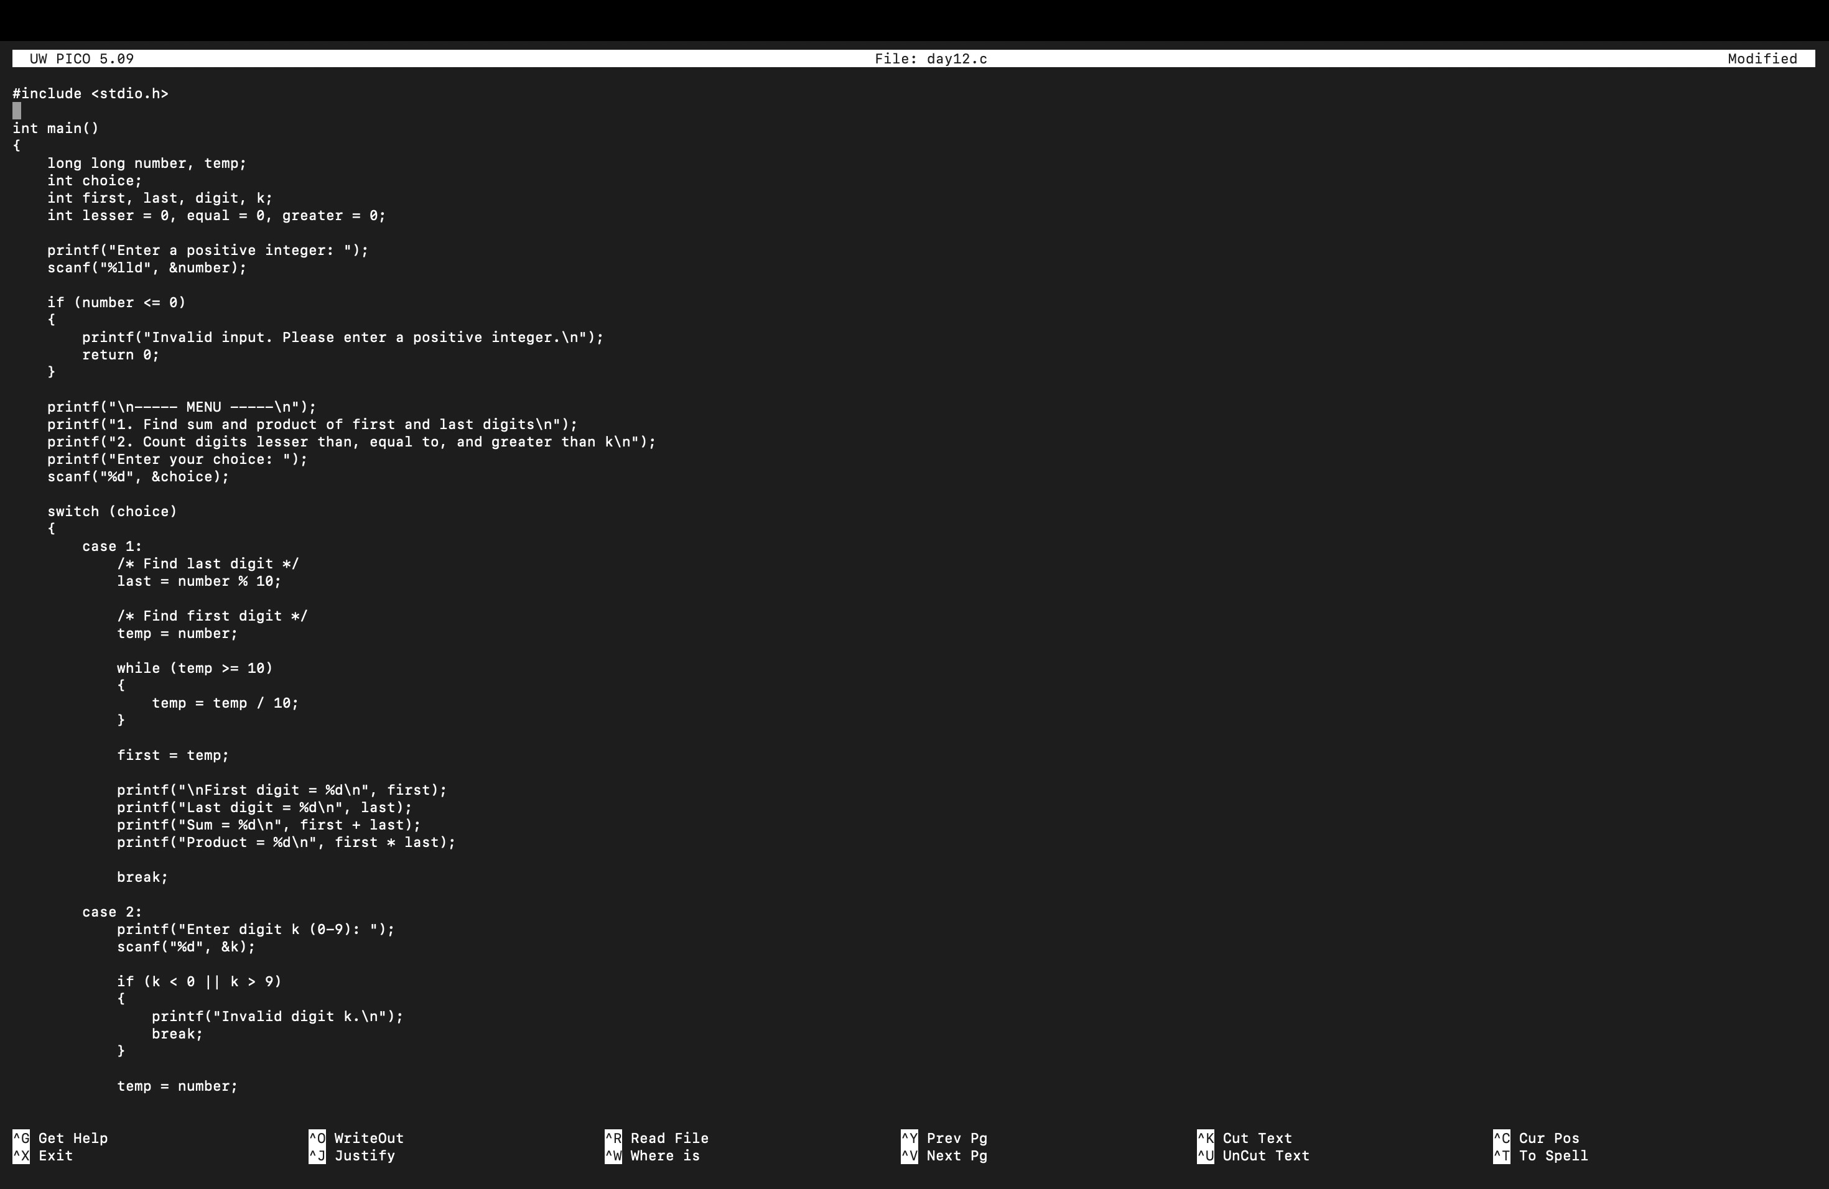
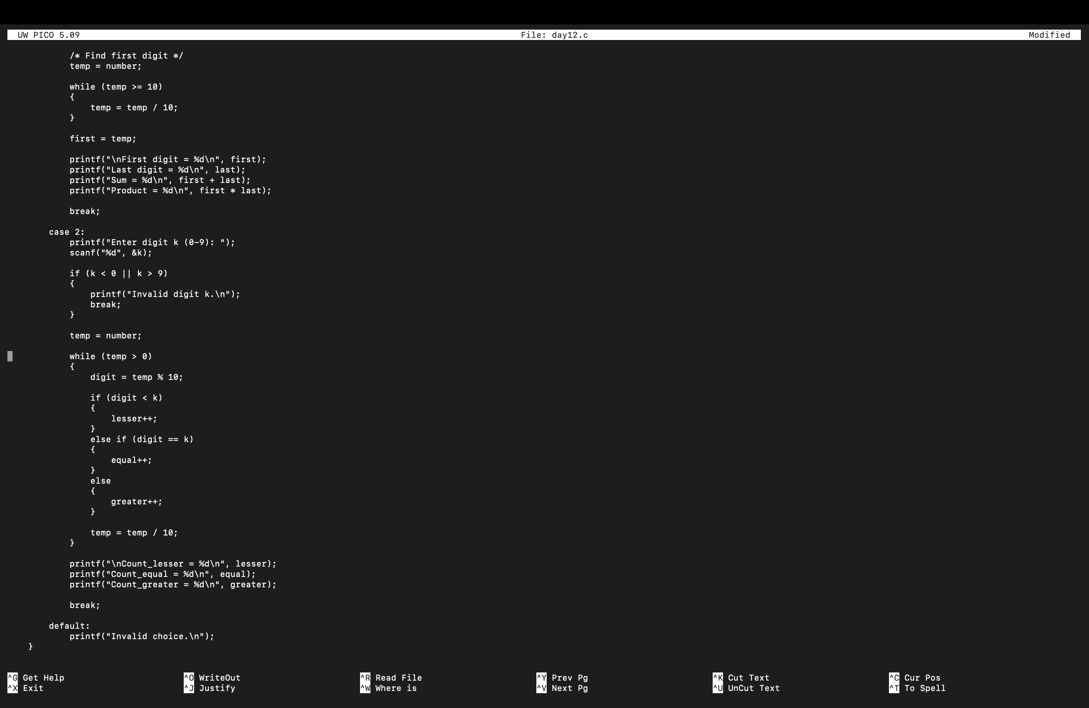
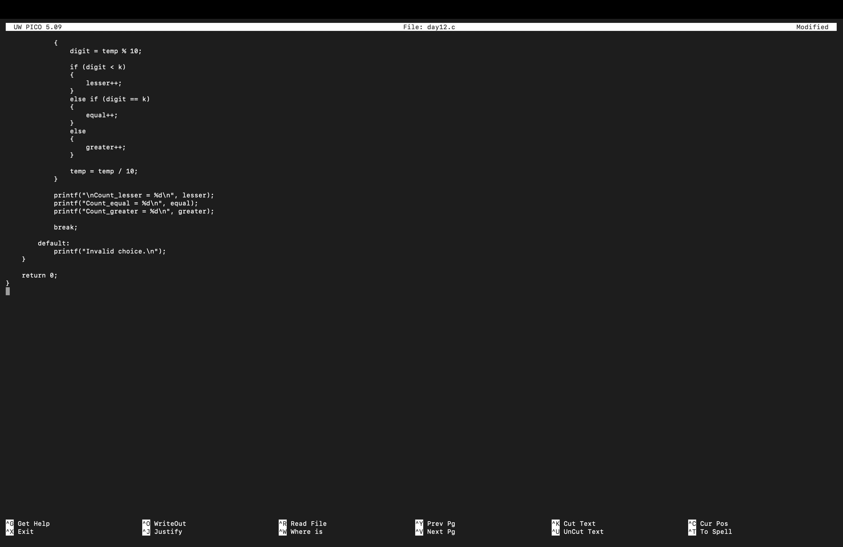
4. Compilation and execution
All 2 Cases Executed successfully
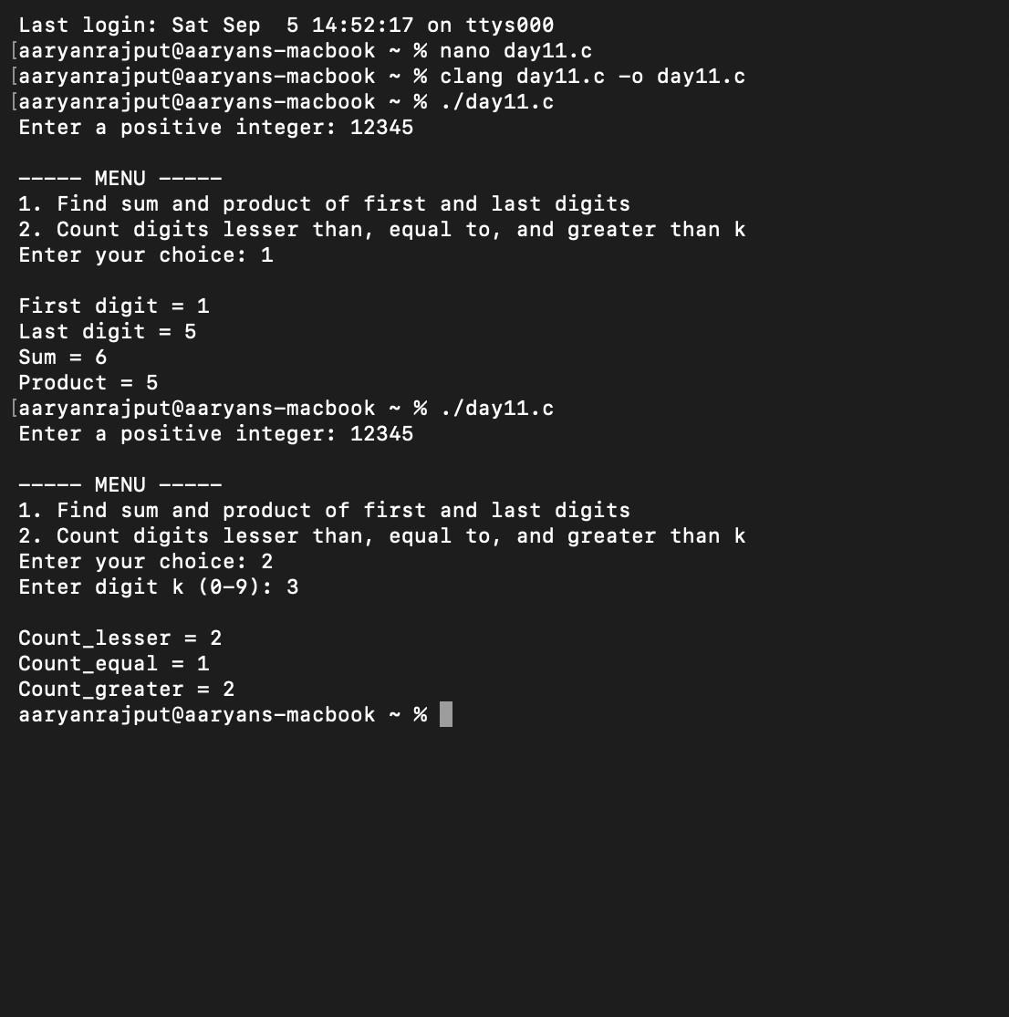
Final Result: The program compiled successfully and produced the expected results for all 4 prepared test cases.

